

SIMATS ENGINEERING

Saveetha Institute of Medical and Technical Sciences
Chennai- 602105

Student Name: Padma Sree.D Reg. No.: 192521241
Course Code: ITA0202 Slot: D
Course Name: Web Technology
Course Faculty: Dr. P. Suresh
Project Title: PetHub: Design and Development of an Integrated Pet Care, Adoption, and Lost & Found Management Portal
Module Photographs:
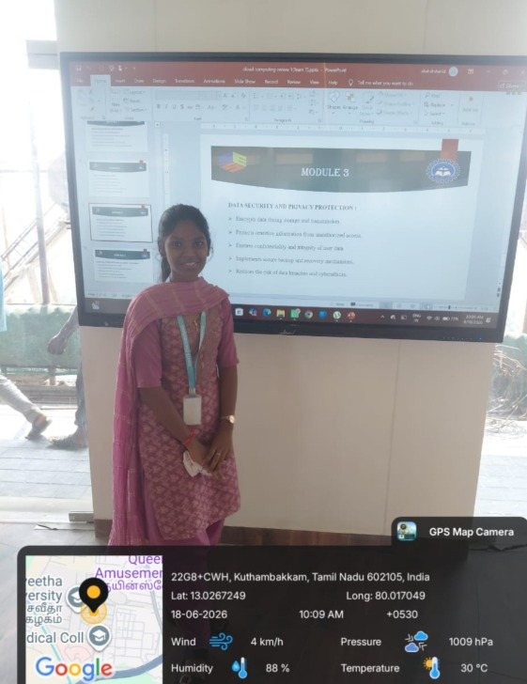
Project Description: Module 1 – User Registration and Pet Profile Management
Module 1 focuses on user registration and pet profile management in the PetHub system. Users can securely register and log in to the portal using their basic personal information.
After registration, users can create and manage their profiles.Pet owners can add detailed information about their pets, including pet name, type, breed, age, gender, health condition, vaccination details, and photographs. Users can view, update, and manage their pet information whenever required.The module stores user and pet details securely in the database. This information provides the foundation for other PetHub features such as pet adoption, pet care services, and lost and found management.
User Registration and Pet Profile Management. In this module, users can register and create their profiles. Pet owners can add their pet details such as name, breed, age, gender, health information, vaccination details, and photos. Users can also update or delete their pet information.
All the data is securely stored in the database. This module provides the basic foundation for the other PetHub services.”

Student Signature Guide Signature

